**MINUTES OF AN EXTRAORDINARY MEETING**

**OF THE**

**RESOURCES COMMITTEE**

**HELD ON 19 JUNE 2019**

**IN THE TOWN COUNCIL OFFICES, LEDBURY**

**PRESENT:** Councillors Bannister, Harvey, Howells (Town Mayor/Committee Chair), Knight and Vesma

**IN ATTENDANCE:** Angie Price – Town Clerk

R1. **APOLOGIES FOR ABSENCE**

Apologies were received from Councillor Whattler.

R2. **DECLARATIONS OF INTEREST**

None received.

R3. **TO APPROVE AND SIGN AS A CORRECT RECORD THE MINUTES OF A MEETING OF THE EXECUTIVE COMMITTEE (Now known as Resources) HELD ON 7 MARCH 2019**

**RESOLVED that the minutes of the meeting of the Executive Committee (now known as Resources) held on 7 March 2019 be approved and signed as a correct record.**

R4. **TERMS OF REFERENCE**

Members were requested to give consideration to the Draft Terms of Reference, which had been deferred to the Committee at the Annual Meeting held on 9 May 2019.

**RESOLVED that a recommendation be made to Full Council that the draft Terms of Reference be approved with no amendments.**

R5. **DATE OF NEXT MEETING**

**RESOLVED to note that the next meeting of the Resources Committee is scheduled for 18 July 2019.**

R6. **EXCLULSION OF PRESS AND PUBLC**

RESOLVED: that in accordance with section 1(2) of the Public Bodies (Admission to Meetings) Act 1960, in view of the confidential nature of the business about to be transacted, it is advisable in the public interest that the press and public are excluded from the remainder of the meeting.

R7. DRAFT JOB DESCRIPTION AND PERSON SPECIFICATION FOR ASSISTANT CEMETERY MAINTENANCE OPERATIVE

Members were requested to give consideration to a draft job description and Person Specification for an Assistant Cemetery Maintenance Operative and a report provided by the Town Clerk advising of the need to fill the vacancy as a matter of urgency.

Members were also requested to give consideration to a suggestion from the Town Clerk that they recruit the post as a “Trainee positon”.

A number of issues were raised during discussion about information that had previously been issued via the committee process, which conflicted with that provided. The Clerk advised that she had been unaware of a number of the points raised, but would look into them.

Concerns were raised in respect of the viability of the job description for the current groundsman post within the Council and it was felt that it would be inappropriate to recruit to a second post until this could be resolved.

RESOLVED:-

1. That the Town Clerk investigate previous information provided to Members in respect of the groundsman positions at Ledbury Cemetery.

2. That the Clerk and Deputy Clerk work with Citation to set up a programme of management in respect of the requirements of the cemetery maintenance in order to provide clearer guidelines on the standard of work expected and staffing levels required.

3. That the Town Clerk provide an interim progress report to the next meeting of the Resources Committee scheduled for 18 July 2019 with a further more definitive report at the following meeting.

R8. ADVERTISING OF VACANCY FOR ASSISTANT CEMETERY MAINTNANCE OPERATIVE

Due to the outcome of agenda item 7 it was agreed that there was no action to be taken on this agenda item.

The meeting closed at 8.30 pm

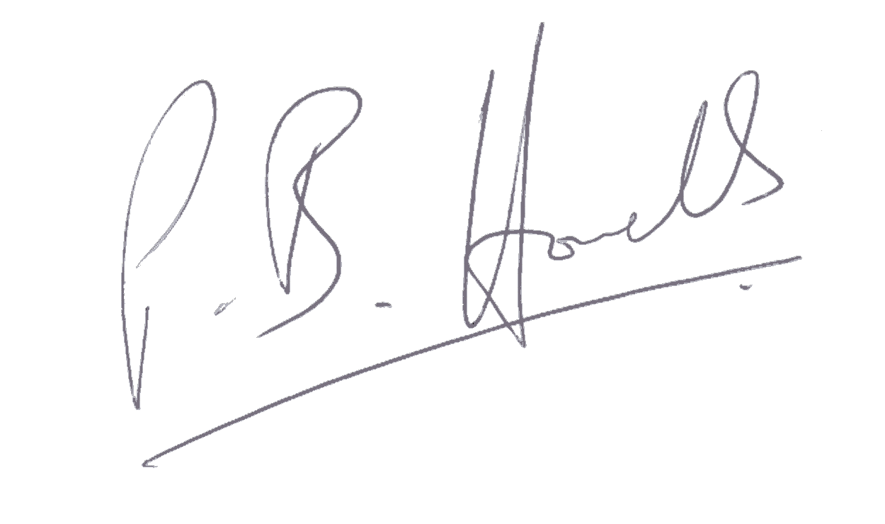Signed Date 18 July 2019