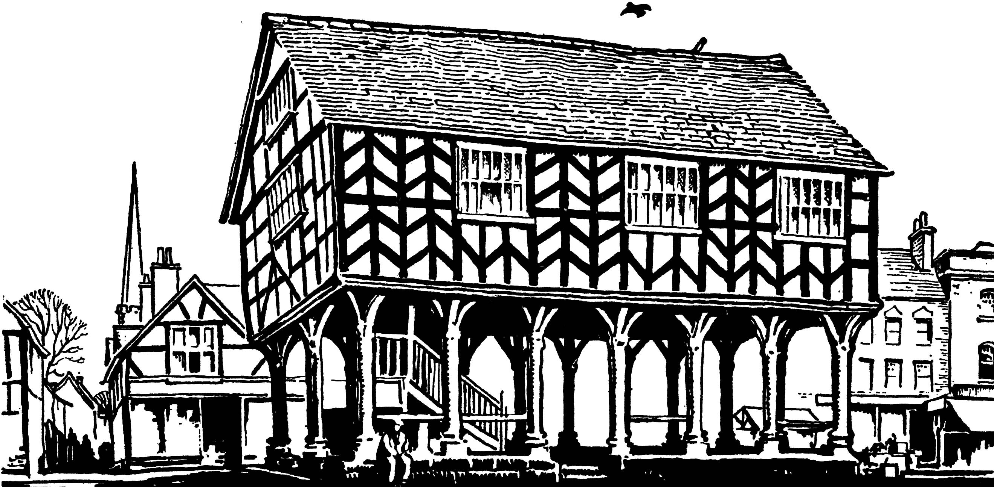
LEDBURY TOWN COUNCIL
TOWN COUNCIL OFFICES . CHURCH STREET . LEDBURY
HEREFORDSHIRE HR8 1DH . Tel. (01531) 632306 Fax (01531) 631193
e-mail: admin@ledburytowncouncil.gov.uk website: www.ledburytowncouncil.gov.uk

Dear Member,
NOTICE IS HEREBY GIVEN that a Meeting of the Economic Development & Planning Committee will be held in the Market House on Thursday 27th August 2015 at 7.30pm. All Committee members are summoned to attend. The business to be transacted is set out in the agenda, which is detailed below.

FILMING AND RECORDING OF COUNCIL MEETINGS
Members of the public are permitted to film or record meetings to which they are permitted access, in a non-disruptive manner. Whilst those attending meetings are deemed to have consented to the filming, recording or broadcasting of meetings, those exercising the rights to film, record and broadcast must respect the rights of other people attending under the Data Protection Act 1998.
Anyone who objects to being filmed or recorded should notify the Clerk or Chairman prior to the commencement of the meeting.

A G E N D A

- Apologies
To receive apologies for absence.

- Interests
To receive declarations of interests in items on the agenda.

3. Public Participation

Members of the public are permitted to make representations, answer questions and give evidence in respect of any item of business included in the agenda. The period of time, which is at the Chairman’s discretion, for public participation shall not exceed 15 minutes. Each member of the public is entitled to speak once only in respect of business itemised on the agenda and shall not speak for more than five minutes. Questions/comments shall be directed to the Chairman.

4. Minutes
To approve as a correct record, the Minutes of the Economic Development and Planning Committee meeting held on 30th July, 2015.
Copy herewith.

5. Planning Applications
To consider the following Planning Applications:-
1. P152130/FH | Proposed removal of existing single storey rear extension and replace with new enlarged garden room at Bank House, Church Lane, Ledbury HR8 1DR.  FULL HOUSEHOLDER
2. P152218 | Proposed loft conversion including modest raising of existing ridge height and the forming of two dormer projections at The Folly, Upperfields, Ledbury HR8 1LE.  FULL HOUSEHOLDER
3. P152334 | Proposed single storey front extension at 30 Russett Close, Ledbury HR8 2XR.  FULL HOUSEHOLDER
4. P/152268 | Proposed works to trees in a conservation area at 19 Worcester Road, Ledbury HR8 1PL.  WORKS TO TREES IN A CONSERVATION AREA
5. P/152269 | Proposed works to trees covered by a Tree Preservation Order at 1 Larkrise, Knapp Lane, Ledbury HR8 1AN.  WORKS TO TREES COVERED BY A TPO
6. P152445 | Proposed works to trees in a Conservation Area at 'Over the Hill', New Street, Ledbury HR8 2DL.  WORKS TO TREES IN A CONSERVATION AREA

6. Planning Application Decisions
To receive a summary showing determinations made by Herefordshire Council on applications previously considered by Ledbury Town Council.
Copy to be circulated at the meeting.

- Correspondence for Information
To note any correspondence received.

8. Date of next meeting and items for future agenda
The next meeting of the Economic Development & Planning Committee is scheduled for 17th September 2015.
Each Councillor is requested to use this opportunity to raise items for inclusion on future agendas.

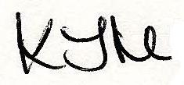
Members of the public and the Press are welcome to attend this meeting.
www.ledburytowncouncil.gov.uk
Mrs K Mitchell
Clerk to the Council
20.08.2015
Tel: 01531 632306

