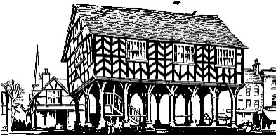
LEDBURY TOWN COUNCIL

15 July 2022

To: Councillors Howells, Hughes, Manns & Morris (Chair)
Non-Councillors: Peter Ascott, Griff Holliday, Lynette Loader, Susie McKechnie & Christine Tustin

Dear Member

You are invited to attend a meeting of the Events Working Party on Thursday, 21 July 2022 at 10.00am at Ledbury Funeral Services (Co-op), Hawcutt Houes, Bye Street, Ledbury, for the purpose of transacting the business below.

Yours faithfully

Angela Price
Town Clerk

FILMING AND RECORDING OF COUNCIL MEETINGS
Members of the public are permitted to film or record meetings to which they are permitted access, in a non-disruptive manner. Whilst those attending meetings are deemed to have consented to the filming, recording or broadcasting of meetings, those exercising the rights to film, record and broadcast must respect the rights of other people attending under the Data Protection Act 1998.

A G E N D A

- Apologies for absence

2. Declarations of Interests

To receive any declarations of interest and written requests for dispensations.
(Members are invited to declare disclosable pecuniary interests and other interests in items on the agenda as required by the Ledbury Town Council Code of Conduct for Members and by the Localism Act 2011)

(Note: Members seeking advice on this item are asked to contact the Monitoring officer at least 72 hours prior to the meeting)

3. Terms of Reference (Pages 69 - 70)

4. Election of non-council members to the Events Working Party

5. To approve and sign the minutes of a meeting of the Events Working Party
held on Wednesday, 29 June 2022 (Pages 71 - 75)

6. Heritage Open Days (Verbal)

7. Poetry Festival, including Ledbury Celebration Day
Feedback (Verbal)

8. October Fair (Verbal)

9. Christmas Lights Switch-on Event (Verbal)

10. Calendar of Events (To Follow)

11. Date of Next Meeting

The date of the next Events Working Party meeting to be held on Thursday, 18 August 2022, at 10.00am, at Ledbury Town Council offices.

